

# Web Designing Assignment

**Term-1**

#### Module (HTML) -1

* Are the HTML tags and elements the same thing?

Ans: No, Html Tags and Elements are not same things. They are different

|  |  |  |  |
| --- | --- | --- | --- |
| **<h1>** | **Tops Technologies** | | **</h1>** |
| **Opening Tag** | **Content** | | **Closing Tag** |
|  |  |  |  |
|  |  |  |  |
|  | **Element** | |  |

An HTML element is the collection of start tag, its attributes, an end tag and everything in between.

An HTML tag (either opening or closing) is used to mark the start or end of an element, as of above Example.

* What are tags and attributes in HTML?

Ans: We Use TAGS to create ELEMENTS in website.

For display Any Information in Website we need to create Elements. Because of ELEMENTS browser can recognize What will be the Headings, what will be Paragraphs etc... in our website. Without Tags we can’t display anything in website.

Attributes are used to add more information to the tag.

<html lang="en">

</html>

As per above Example <html> </html> are tags. lang=”en” is attribute. Attribute give more information that this page will be in English language <Html lang=”en”>. Attributes always specified in the start tag.

* What are void elements in HTML?

Ans: In HTML some elements only have start tags and does not contain any content within it, these elements are called void elements. Void elements don’t have ending tags and can only have attributes but do not contain any kind of content.

* What are HTML Entities?

Ans: HTML entities are the reserved characters that are used in the HTML document. They are not present in keyboard. They provide a wide range of characters, allowing add icons, geometric shapes, mathematical operators etc…

Example:

    <a href="home.html"> HOME </a> &nbsp; &nbsp;&nbsp;&nbsp;

    <a href="car.html"> CARS </a> &nbsp; &nbsp;&nbsp;&nbsp;

    <a href="bike.html"> BIKE </a> &nbsp; &nbsp;&nbsp;&nbsp;

    <a href="ccycle.html"> CYCLE </a>

&nbsp; For non-breaking space

* What are different types of lists in HTML?

Ans: There are three different types of HTML lists.

1. Ordered list <ol>
2. Unordered list <ul>
3. Description list <dl>

* What is the ‘class’ attribute in HTML?

Ans: The HTML ‘class’ attribute is used to specify a single or multiple class names for and HTML

element. A class attribute can be defined within <style> tag.

* What is the difference between the ‘id’ attribute and the ‘class’ attribute of HTML elements?

Ans: The ‘id’ attribute is a unique identifier that is used to specify the document.

The ‘class’ attribute is used to specify one or more class names for an HTML element.

difference between the ‘id’ attribute and the ‘class’ attribute is that “id” is unique in a page and can only apply to at most one element. While “class” attribute can apply to multiple elements.

* What are the various formatting tags in HTML?

Ans: Formatting is a process of formatting text for better look and feel.

Formatting tags are divided into two categories

* Physical tag: These tags are used to provide the visual appearance to the text
* Logical tag: These tags are used to add some logical or semantic value to the text

1. <b> : This is physical tag. Which is used to bold the text written between it.
2. <strong> : This is logical tag, which tells the browser that the text is important
3. <i> : This is physical tag which used to make text italic
4. <em> : This is logical tag which is used to display content in italic.
5. <mark> : This tag is used to highlight text.
6. <u> : This tag is used to underline text written between it.
7. <sup> : This tag displays the content slightly above the normal line.
8. <sub> : This tag displays the content slightly below the normal line.
9. <del> : this tag is used to display the deleted content.
10. <big> : This tag is used to increase the font size.
11. <small> : This tag is used to decrease the font size.

* How is Cell Padding different from Cell Spacing?

Ans:

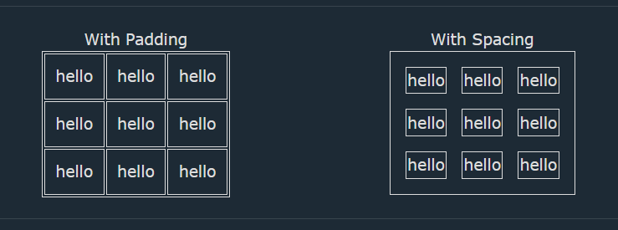

As per above image example the distance between cells in a grid layout is known as cell spacing, and space around each cell is known as cell padding.

* How can we club two or more rows or columns into a single row or column in an HTML table?

Ans: We can Club two or more rows with <rowspan> tag in tables.

We can club two or more columns with <colspan> tag in tables.

* What is the difference between a block-level element and an inline element?

Ans: **Block-Level elements** takes up the full width of the content. They always start in a new line and have top and bottom margins.

Example: <div>, <p>, <li>, <ul>, etc.…

**Inline elements** occupy only enough width that is sufficient to it and allows other elements next to it which are inline. Inline elements don’t start from a new line and don’t have top and bottom margins as block elements have.

Example: <a>, <br>, <img>, <span>, etc…

* How to create a Hyperlink in HTML?

Ans: Hyperlinks can be created by <a> tag. It has the following syntax:

<a href="url">link text</a>

* What is the use of an iframe tag?

Ans: <iframe> tag is used to embed a webpage within a webpage.

“iframe” stands for **Inline Frame.**

The <iframe> tag defines a rectangular region within the document in which the browser can display a separate document.

* What is the use of a span tag? Explain with example?

Ans: The <span> tag is inline HTML element used to apply styles or manipulate specific portions of text within a larger block of content.

Example:

<!DOCTYPE html>

<html>

<body>

    <h2>Welcome To Tops Technologies</h2>

    <p>

        Tops Technologies

        <span style="color:red;font-weight:bolder">

            IT career solution

        </span> portal for

        <span style="background-color: lightgreen;">

            all IT aspiriants

        </span>.

    </p>

</body>

</html>

**Output:**

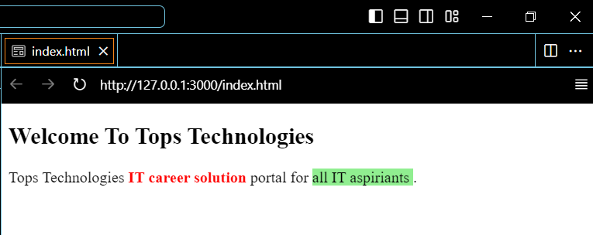

* How to insert a picture into a background image of a web page?

Ans: In the <body> giving background attribute by passing the URL or location of the image.. we can insert picture into a background image of a web page

<body background = "URL or path" > Website Body </body>

* How are active links different from normal links?

Ans: An **Active link** is a hyperlink that is currently being interacted with the user.

In **Normal link** is a hyperlink that is not yet clicked by the user.

* What are the different tags to separate sections of text?

Ans: We separate a section of texts in HTML using the below tags:

1. <br>tag : It is used to separate the line of text.
2. <p> tag : This tag us used to write a paragraph of text.
3. <blockquote> : This tag is used to define large quoted sections.

* What is SVG?

Ans: **SVG** stands for **Scalable Vector Graphics**

HTML SVG is a language which is used to describe graphics in XML.

SVG images and their behaviors are defined in XML text files.

* What is difference between HTML and XHTML?

Ans: **XHTML** stands for Extensible Hypertext Markup Language.

XHTML has a stricter syntax compared to HTML.

XHTML follows the syntax rules of XML, which is standard markup language.

**HTML** is the Hypertext Markup Language. It is used to create web pages and link them from one to another.

Html is easier to code compared to XHTML

* What are logical and physical tags in HTML?

ANS: We use logical and physical tags for formatting the text

Physical tag: These tags are used to provide the visual appearance to the text

Example:

<b> : This is physical tag. Which is used to bold the text written between it.

<i> : This is physical tag which used to make text italic

Logical tag: These tags are used to add some logical or semantic value to the text

Example:

<strong> : This is logical tag, which tells the browser that the text is important

<em> : This is logical tag which is used to display content in italic.